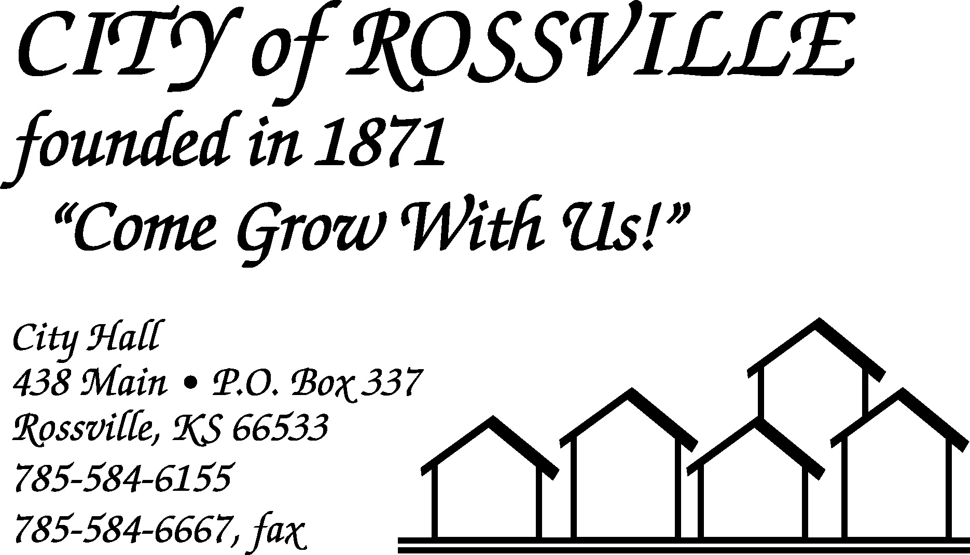

City Hall July 6, 2021

Due to the holiday on Monday the Rossville City Council meeting was called to order on Tuesday, July 6, 2021 at 7:03 pm by Mayor Kenneth Wichman.

Council members present were Dan Glotzbach, Christi McKenzie, James Meyer and Toby McCullough. Trish Heim was absent.

Also present were Jason Connell and Alan Zlatnik.

Motion by Toby McCullough to approve minutes of the June 21, 2021 meeting as written was seconded by James Meyer and carried.

The following bills were presented;
Fastdraws $ 35.91 Alan Zlatnik $1,427.11
Fed WH 1,113.95 FICA 2,136.90
Tracey Taylor 859.93 EMPower Retirement 380.00
Lisa Stum 1,234.81 Grace Hier 60.00
Michael Kirk 1,286.91 Randall Anderson 935.45
Kansas Payment Center 247.46 Bowe Behymer 616.61
Kansas Withholding Tax 520.43 Douglas Schreiner 218.07
KP & F 1,050.40 KPERS 1,405.07
Trent Stanley 1,096.22 Jacob Akin 226.79
Jason Connell 916.65 Kerry Dick 433.66
Harry Hammer III 223.71 Tina Dick 442.35
Frederick White 73.21 Yahoo 23.99
Ks. State Treasurer-Court Fees 620.00 Amazon.Com 238.10
KTA Tolls 20.60 Office Depot 65.47
CenturyLink 767.58 FICA 702.02
Kansas Gas Service 97.59 Ks Employment Security Fund 97.02
Shawnee Co. Solid Waste Dept. 7,169.52 U.S. Post Office 14.74
Alan Streit 507.92 Aramark 147.90
D & D Security 24.95 DH Lawn & Garden Equipment 63.98
Ferguson Enterprises, Inc 549.99 Galls LLC 41.99
KDHE 20.00 MARC 341.08
Menards 490.10 Networks Plus 42.90
Roberson Lumber Co., Inc. 16.28 Rossville Auto Supply 108.33
Universal Chemical LLC 259.20 Evergy 1,756.30
USA Blue Book 317.71 Wehner’s Thriftway 534.61
Zoom Communication 14.99
TOTAL 31,996.46

Motion by Dan Glotzbach to pay bills as presented totaling $31,996.46 was seconded by Toby McCullough and carried.

Motion by Christi McKenzie to approve agenda as written was seconded by James Meyer and carried.

Mayor noted that he had missed the last couple meetings due to health issues.

Mayor noted that WTC were working in Rossville in various locations.

Clerk reported that Beyond Baseball has made payment of lease and would still owe $500.00 after applying deposit. Council had discussion regarding problems with locations of bull pens and type of fencing used. No action was taken.

Utility Superintendent Alan Zlatnik reported that Shawnee County would be addressing the drainage culvert issue at 239 Main Street.

Superintendent Zlatnik noted that there may be issues with fences that were constructed in alley easement in the 200 block of Main/Navarre as WTC work to run lines.

Superintendent Zlatnik reported that the annual sewer cleaning was starting this week. One third of the towns main sewer lines are cleaned each year on a rotating basis.

Superintendent Zlatnik reported that they have been spraying for mosquitos and would be spraying again tonight.

Superintendent Zlatnik presented park maintenance schedule and reported that the park play equipment has been power washed. Council noted that the park was looking great. Zlatnik noted that the tree stumps would need to be removed and that he was looking at planting maple tree in the area where the pine trees had been.

Police Chief Jason Connell reported that tomorrow the police department would issue citations to code violations that have not been resolved.

Chief Connell also reported that there had been no issues with 4th of July celebrations or Silver Lake celebration at the Legion.

Toby McCullough reported that he had bid from Brandon Bergstresser to construct Rossville City limit signs at north and south entrances to town. Cost would be $2,850.00 for each sign or $3,250.00 for each sign plus footings. McCullough reported that the Rossville Community Foundation would consider cost sharing on this project. Council had discussion regarding location of north sign if repairs made to drainage ditch. No action was taken at this time.

Council reviewed 2022 budget numbers for the general fund. No action was taken.

Motion by James Meyer to adjourn was seconded by Toby McCullough and carried. Meeting adjourned at 8:10pm.

City Clerk
Lisa M. Stum

